1. Create a Sales Dictionary:

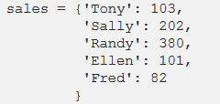

And Region Dictionary:

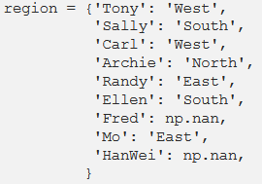

1. Create Sales Dataframe and Region Dataframe using above Dictionaries

**note**: pd.DataFrame.from_dict()

1. Write the python command to get the below output:

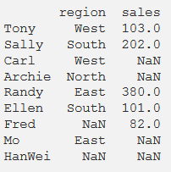

1. Write the python command to get the below output:

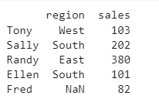

1. Write the python command to get the below output:

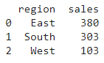

1. Write the python command to get the below output:

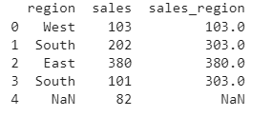

1. Write the python command to get the below output:

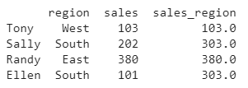

1. Write the python command to get the below output:

